REFILL INSTRUCTIONS FOR ZAG CANISTERS

DISCONNECT ELECTRICAL CORD, OUTPUT, AND DRAIN. ALLOW SYSTEM TO COOL.

A198 – ZEOLITE (MB105) Media color is white
A199 – PURAFIL / PURAKOL (MB106) Media color is black
A199 – PURAFIL / SELECT (MB107) Media color is purple

Remove cover on system
Place system on side and remove 4 nuts that mount each sub–assembly
Note: Assemblies should not fall out, tubing will hold in place
Place system upright and remove hardware from side panels

A198 Canister Removal:
Fittings are push collar to remove and install tubing
Disconnect tubing at tee and remove the input tee from top of canister
Raise assembly to disconnect tubing from valve on back of bracket
Remove canisters from bracket
Replace media as outlined on page 2
Re-install canisters, and reconnect as originally configured

A199 Canister Removal:
Remove tubing on top of canisters using a 9/16 wrench
Remove MB107 canister, pull out of bracket, and disconnect tubing from bottom of canister
Raise bracket to remove MB106 canister from bracket and disconnect tubing from bottom of canister
Replace media as outlined on page 2
Ensure MB107 canister is on outside of system, flow arrows are up, and tubing connects to coil
Ensure MB106 flow arrows are down and tubing connects to regulator on front panel
Re-install canisters, and reconnect as originally configured

Secure brackets to chassis
Secure side panels and cover

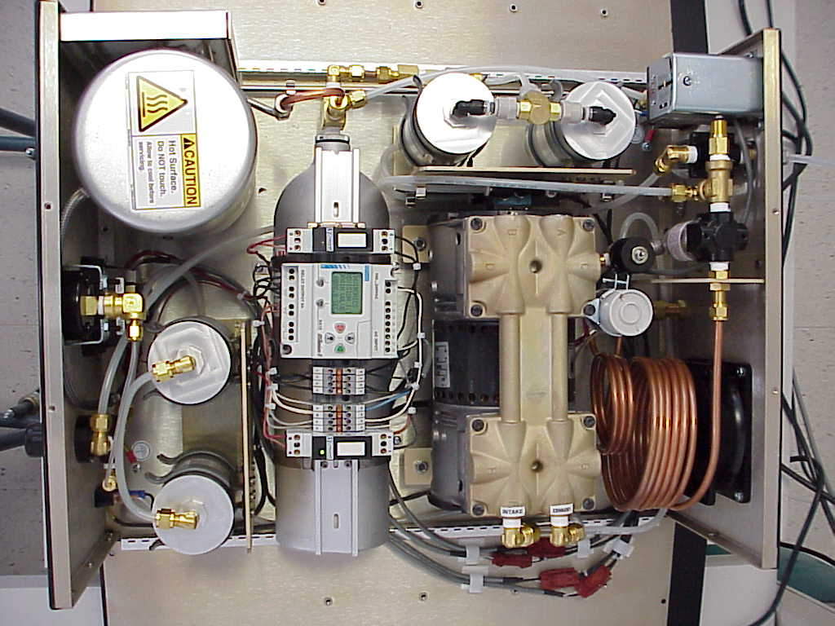

RUN SYSTEM TO PURGE FOR 2 HOURS BEFORE USE

REPLACING MEDIA AND FILTERS IN ALL CANISTERS

Each canister needs to be re-built independently. Caps must be re-installed on original side of canister.

Removing filters, o – rings, and media:
Unscrew caps with 7/8 wrench
Carefully remove felt filter
Dispose of media, felt filters, and o – rings

Replacement of filters, o-rings, and media:
Thoroughly clean inside of canister and threads on the caps
Use the pre-lubricated replacement 0-rings and place on caps
Thread one cap on canister and tighten
Install replacement felt filter into canister flat against capped end
Replace with correct media as labeled on canister
Fill canister 3/4 inch from top
Press felt filter flat against the media and tighten top cap
Note: Ensure media is not outside of felt filter before capping canister, or it will contaminate and or clog system output

